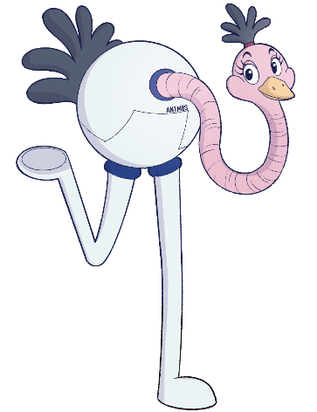
GEOGRAPHY
Introduction by Stretch, our Geography expert!
The Animates: River of Life provides opportunities for pupils to develop their geography knowledge and understanding by exploring concepts linked to Merseyside’s maritime industry. Through activities exploring their locational and place knowledge and physical geography, pupils can make connections between the maritime industries and other sectors.
Objectives
- Develop contextual knowledge of location in the Liverpool City Region and communicate geographical information in a variety of ways.
- KS1 – Locational knowledge: the names of the seven continents and five oceans. Basic human geographical vocabulary (city, town, port) and physical geographical vocabulary (beach, sea, ocean, river). Use maps and simple compass directions to describe locations, features, and routes on a map. Use aerial views to recognise landmarks.
- KS2 – Name and locate the world’s countries and major cities using maps. Use maps, atlases, globes and computer mapping to locate countries. Use eight points of a compass to build knowledge of the wider world.

Activities
Location Quest!
Pupils see the attached map of the Liverpool City Region. Together, identify the key features on this map such as the River Mersey, the beach, the Liver Buildings, the city centre, the football stadiums, roads, and neighbourhoods (see page 3 for a list of Areas of Interest in the story).
Explain that the Liverpool City Region is made up of six boroughs (Sefton, Liverpool, Knowsley, Wirral, Halton and St Helens).
Ask pupils: Which borough are you from?
Ask pupils to locate the businesses that are featured in The Animates: River of Life story on the map.
Pupils then put themselves on the map by locating their school or street/neighbourhood.
Ask pupils to answer the following questions:
- Which business is closest to our school?
- Which business is furthest?
- What borough are the different businesses in?
Extension activity: Pupils find these addresses on Google Maps, using the aerial (satellite) view. What landmarks can they see?
Pupils create a mini travel plan: If we were to visit one of these businesses from our school, which route would we take? Would we go by bus, train, or walking?

Compass Quest
Pupils learn how to hold and use a compass, identify the eight points of the compass, and use them to follow directions.
Show pupils page 12, where Sea Dog uses his Compass of Light to help guide them.
The compass has eight points (N, NE, E, SE, S, SW, W, NW).
Ask pupils: What do these letters mean? Can you find which way North is in your classroom?
Ask pupils to answer the following questions:
- Between North and East = ________
- Between South and West = ________
- Between North and West = ________
- Between South and East = ________
Extension activity: Take pupils out to the playground or the hall to follow the Compass Quest.
(If you have compasses then great; if not, label North, South, East and West with paper or stickers.)
Tell pupils to follow your quest – for example:
“Take 3 steps North, turn and walk 2 steps East, now go 4 steps South-East, finally, walk 1 step West.”
Could pupils create their own quest around school using compass directions?

Travel Agents
On page 20, there is a signpost with signs pointing to lots of different cities and countries.
Ask pupils to:
- Find each of these locations on a map.
- Identify whether the place is a city or a country.
- Identify which continent the city or country is located in.
- Identify which place is closest to Liverpool.
- Identify which place is furthest from Liverpool.
The following page shows the team boarding a “colossal cruise liner” at Liverpool’s Cruise Terminal.
Ask pupils: If you were the Captain, what country would you visit and why?

The River of Life
A key part of the story is the River Mersey.
Show pupils a picture or map of the River Mersey.
Ask: What do we already know about the River Mersey?
(e.g. where it is, what it looks like, what happens on it – ferry, cruise ships, cargo ships, drive under it through the tunnel, etc.)
Tell pupils they will be comparing water types. Ask pupils to match the definition to the word. Focus on River, Sea, Ocean and Lake.
Demonstrate the journey from river to ocean with the Mersey:
“The River Mersey flows into the Irish Sea. The Irish Sea is part of the Atlantic Ocean. The Atlantic Ocean connects to all the other oceans of the world!”
Show this journey on a map, tracing from the River Mersey outwards.
Provide pupils with a world map or globe.
First, remind them of the names of the five oceans: Pacific, Atlantic, Indian, Southern and Arctic.
Ask pupils to label or colour the oceans.
Ask pupils: Which is the smallest ocean? Which is the largest? etc

Extension Activity: The last page of the book has the fact:
“The ocean covers 71% of our planet and the scientists at the National Oceanography Centre in Liverpool use robots and high-tech tools to study everything from coastlines to the deep sea. They protect the planet and keep our oceans healthy.”
Why not ask Bam Bam to tell pupils more about the National Oceanography Centre? Visit the Animates website here Ask Bam Bam | The Animates

